Lisa 5. Supplementary information on the results, material and methods for setting GES thresholds for Reproductive disorders: malformed embryos of amphipods, the inficator of biological effects of chemical contaminants in sediment.

Table 1. Material used for setting GES thresholds for reproductive aberrations in the amphipod Monoporeia affinis (gravid females) in the Gulf of Finland and the Gulf of Riga. The stations were selected based on the expert opinion regarding general disturbance levels; the representative geographic coverage of the subbasin was considered (Fig. 1).
Subbasin | Station | Year | Number of gravid females | Number of embryos | Country
Gulf of Finland | 2 | 2016 | 31 | 693 | Estonia
Gulf of Finland | 3 | 2016 | 45 | 1133 | Estonia
Gulf of Finland | 18a | 2016 | 21 | 678 | Estonia
Gulf of Finland | HR50 | 2016 | 27 | 890 | Estonia
Gulf of Finland | N12 | 2016 | 27 | 971 | Estonia
Gulf of Finland | M | 2020 | 36 | 884 | Estonia
Gulf of Finland | J3 | 2020 | 6 | 105 | Estonia
Gulf of Finland | N12 | 2020 | 60 | 1820 | Estonia
Gulf of Finland | N | 2020 | 4 | 99 | Estonia
Gulf of Finland | N8 | 2020 | 47 | 901 | Estonia
Gulf of Finland | 2F | 2020 | 12 | 184 | Russia
Gulf of Finland | 3F | 2020 | 17 | 287 | Russia
Gulf of Finland | 4F | 2020 | 14 | 190 | Russia
Gulf of Finland | 9F | 2020 | 26 | 437 | Russia
Gulf of Finland | 2ug | 2020 | 34 | 549 | Russia
Gulf of Riga | 114A | 2020 | 11 | 206 | Latvia
Gulf of Riga | 111LV | 2020 | 22 | 470 | Latvia
Gulf of Riga | VAD2 | 2020 | 50 | 1657 | Latvia
Gulf of Riga | 101A | 2020 | 24 | 395 | Latvia
Gulf of Riga | G3 | 2021 | 30 | 527 | Latvia
Gulf of Riga | 163B | 2020 | 50 | 1017 | Latvia
Gulf of Riga | 162B | 2020 | 49 | 940 | Latvia
Gulf of Riga | 160B | 2020 | 11 | 278 | Latvia
Gulf of Riga | 107 | 2020 | 7 | 158 | Latvia
Gulf of Riga | 111EE | 2021 | 25 | 573 | Estonia
Gulf of Riga | L9 | 2021 | 12 | 260 | Estonia
Table 2. Background assessment criteria (BAC) and environmental assessment criteria (EAC) values for each indicator component and subbasin. See Figs 2 and 3.
Subbasin | Assessment criteria | Mean | BAC | EAC
BoS, WGB | Proportion of aberrant ambryos
 | Proportion of females with >1 aberrant embryo
GoF | Proportion of aberrant ambryos | 0.05 | 0.07 | >0.07
 | Proportion of females with >1 aberrant embryo | 0.40 | 0.52 | >0.52
GoR | Proportion of aberrant ambryos | 0.04 | 0.06 | >0.06
 | Proportion of females with >1 aberrant embryo | 0.14 | 0.22 | >0.22

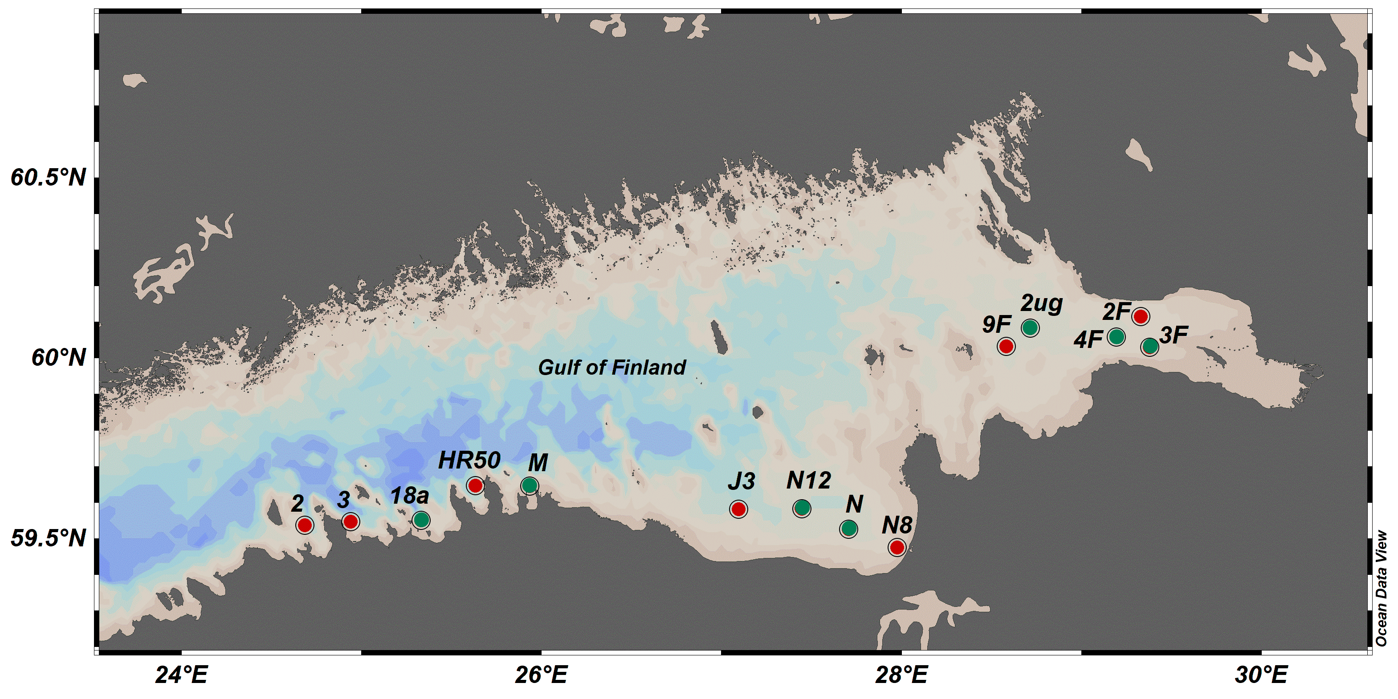
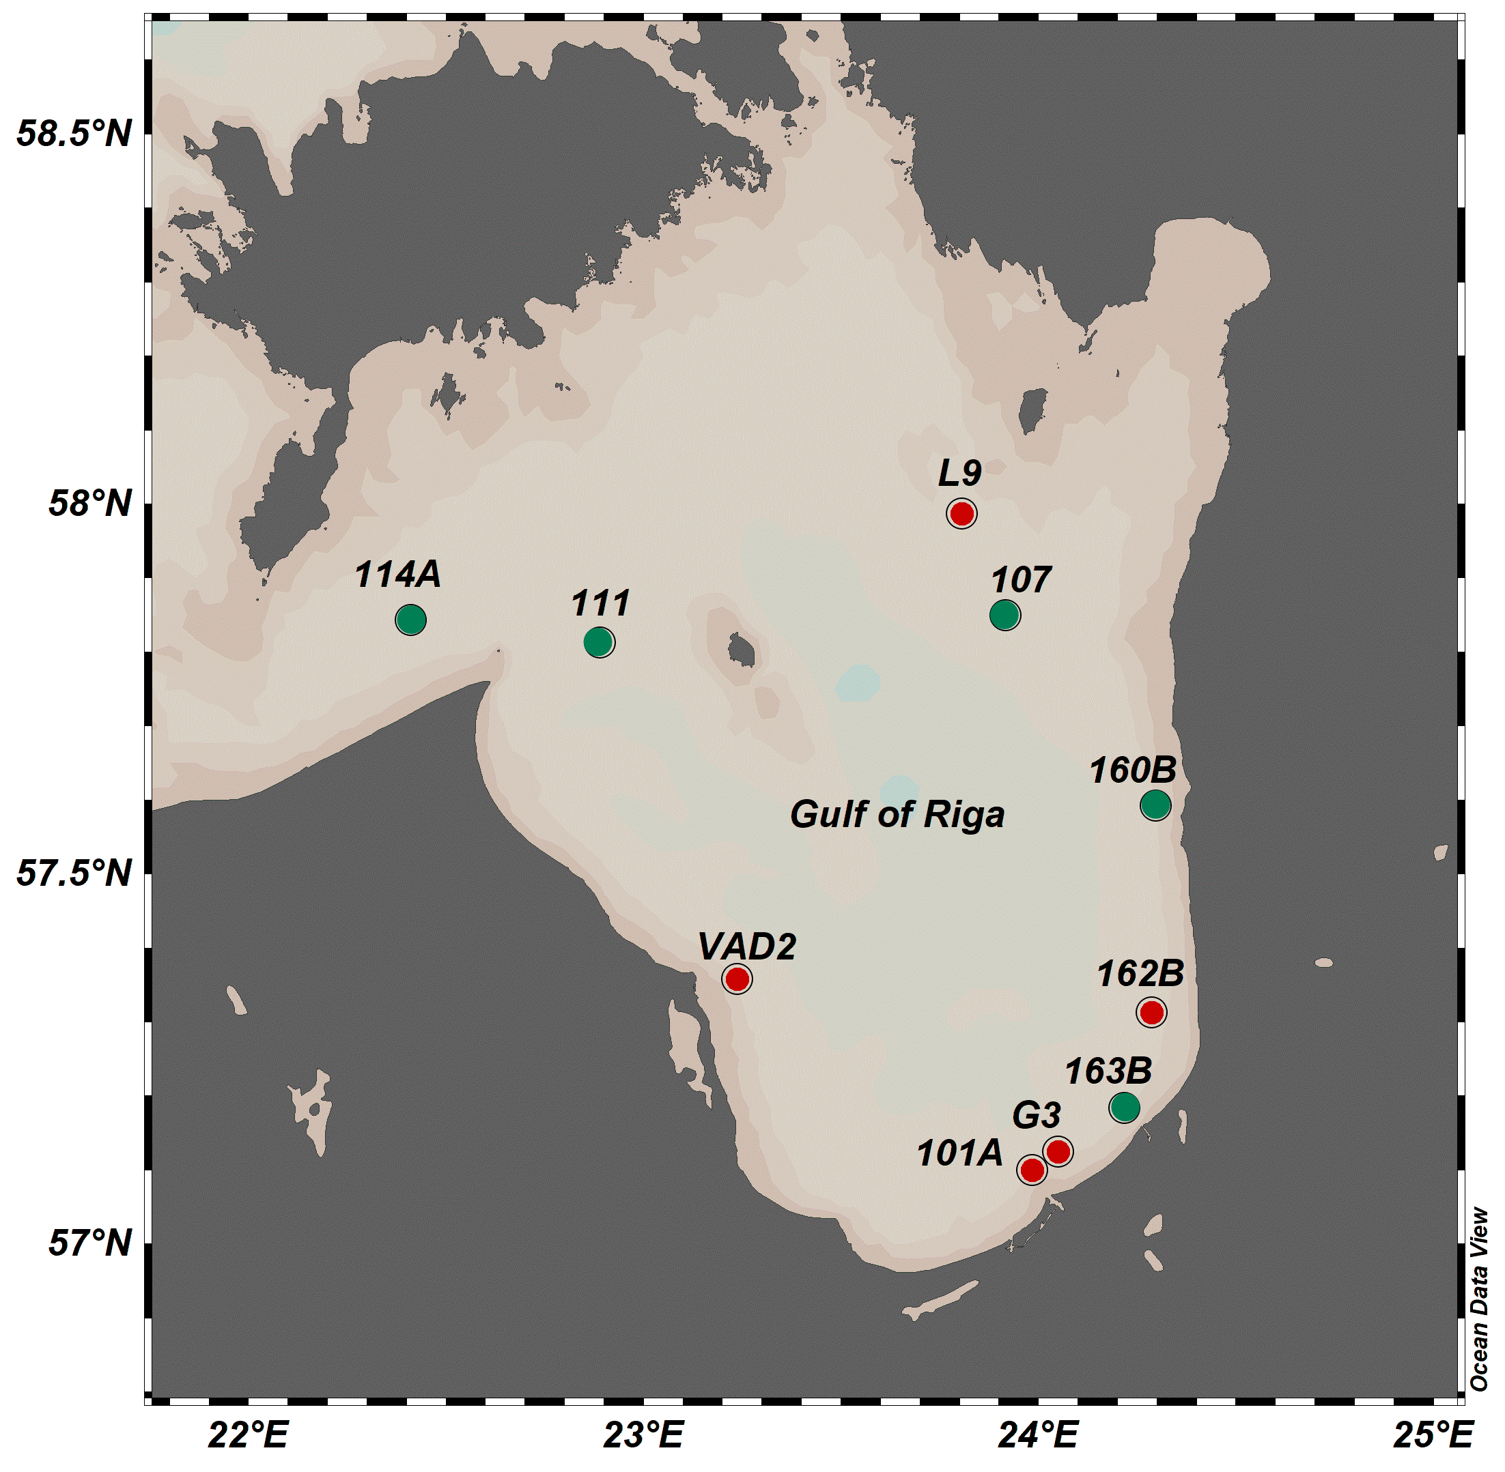

Figure 1. Amphipod collection sites in the Gulf of Finland (upper panel) and the Gulf of Riga (lower panel). The stations were selected based on the expert opinion regarding general disturbance levels and observations in various surveys; the representative geographic coverage of the subbasin was also considered. The reference stations (green) were selected based on the expert opinion and data from specific surveys and other monitoring programmes, including chemical contaminants in sediment, conducted by the respective laboratories. Data from the red stations will be added to conduct the assessment for 2016-2021.
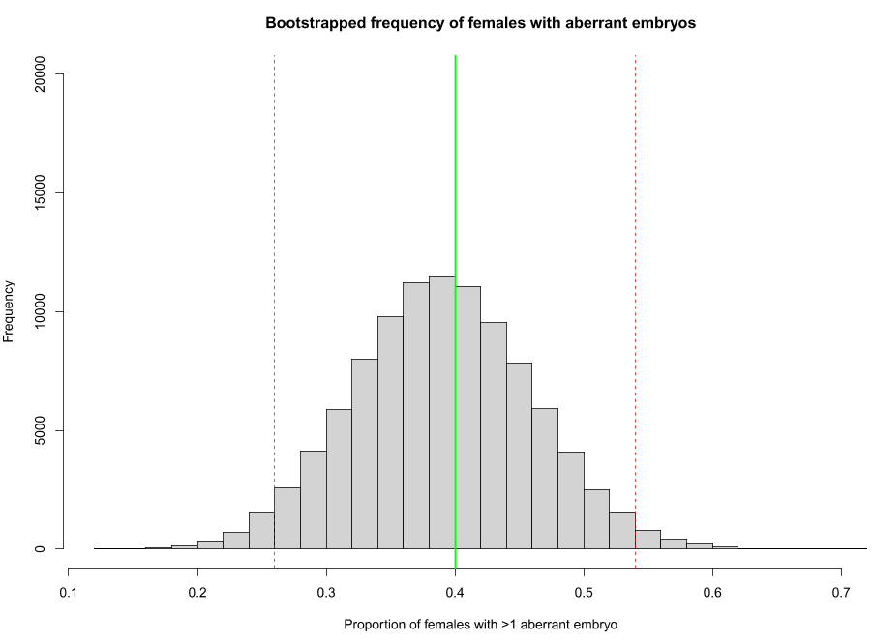
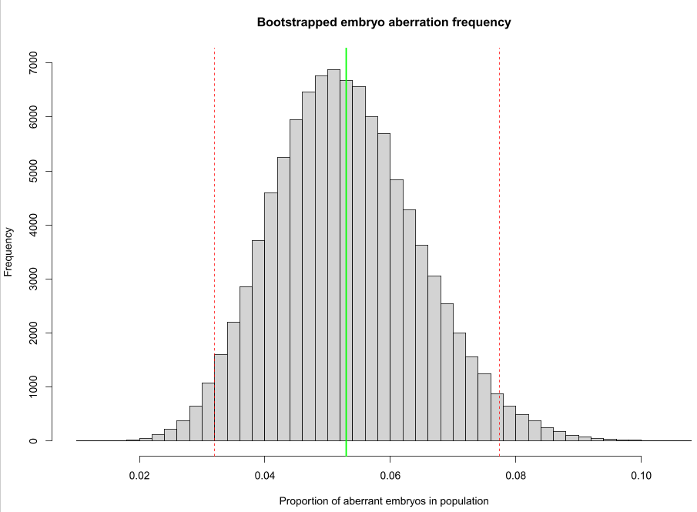
Figure 2. Gulf of Finland: background variability in the embryo aberration frequency in the amphipod Monoporeia affinis population: (a) proportion of aberrant embryos; and (2) proportion of females with more than one aberrant embryo. Green line indicates the population mean and dotted red lines indicate 90%-confidence interval around the mean.
B
A
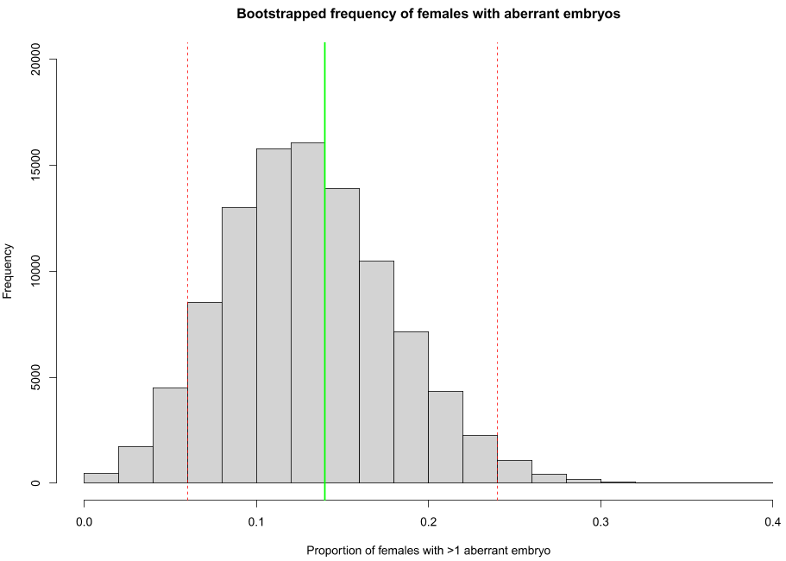
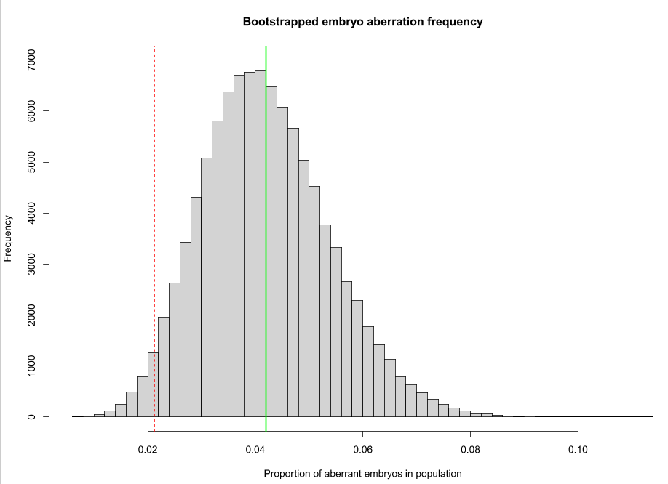

Figure 3. Gulf of Riga: background variability in the embryo aberration frequency in the amphipod Monoporeia affinis population: (a) proportion of aberrant embryos; and (2) proportion of females with more than one aberrant embryo. Green line indicates the population mean and dotted red lines indicate 90%-confidence interval around the mean.

